1. Into - Need of Adapter

Adapter is a structural design pattern that allows objects with incompatible interfaces to collaborate.
The Scenario: You are building a modern Stock Market Dashboard.
- The Component: You bought a fancy 3rd-party charting library (FancyCharts) that generates beautiful graphs. It strictly requires JSON input.
- The Data Source: Your data comes from a 20-year-old legacy Stock Feed server. It strictly returns XML.
The Crash: You cannot pass the XML string into the JSON library. It will throw a syntax error immediately.
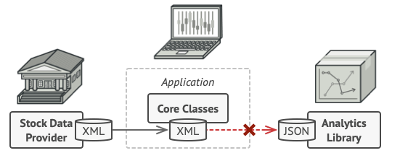

namespace NeedOfAdapter
{
// 1. The Legacy System (Returns XML)
public class StockFeed
{
public string GetStockData()
{
return "<stocks><stock><symbol>AAPL</symbol><price>150</price></stock></stocks>";
}
}

// 2. The Modern Chart Library (Expects JSON)
public class FancyCharts
{
public void RenderChart(string data)
{
if(data.Trim().StartsWith("{") == false)
{
throw new Exception("Data is in JSON format. Cannot render!");
}
Console.WriteLine($"Rendering data: {data}");
}
}

// 3. The Client (Fails)
public class DashboardApp
{
public void ShowCharts()
{
StockFeed feed = new StockFeed();
FancyCharts chart = new FancyCharts();

// CRITICAL ERROR: Incompatible Formats
//chart.RenderChart(feed.GetStockData()); // THROWS EXCEPTION
}
}

public class Program
{
public static void Main(string[] args)
{
DashboardApp app = new DashboardApp();
app.ShowCharts();
}
}
}

2. Solution Using Adapter

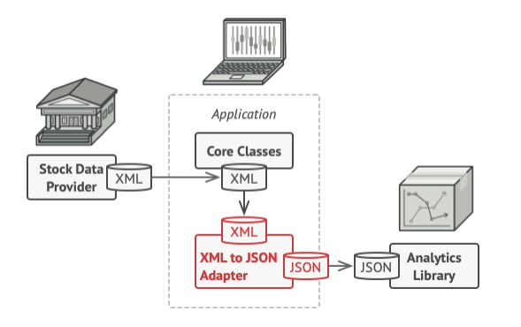

using Newtonsoft.Json;
using System.Xml;

namespace XMLToJson
{

// 1. The Legacy System (Returns XML)
public class StockFeed
{
public string GetStockData()
{
return "<stocks><stock><symbol>AAPL</symbol><price>150</price></stock></stocks>";
}
}

// 2. The Modern Chart Library (Expects JSON)
public class FancyCharts
{
public void RenderChart(string data)
{
if (data.Trim().StartsWith("{") == false)
{
throw new Exception("Data is in JSON format. Cannot render!");
}
Console.WriteLine($"Rendering data: {data}");
}
}

// 3. Adapter
// The Interface (What the Client expects)
// "I need a provider that gives me JSON string"
public interface IJsonDataAdapter
{
string GetJsonData();
}

public class XmlToJsonAdapter : IJsonDataAdapter
{
private readonly StockFeed _stockFeed;
public XmlToJsonAdapter(StockFeed stockFeed)
{
_stockFeed = stockFeed;
}
public string GetJsonData()
{
// Step A: Get the data in the original format (XML)
string xmlDocument = _stockFeed.GetStockData();

// Step B: Convert it (The "Adaptation" logic)
XmlDocument doc = new XmlDocument();
doc.LoadXml(xmlDocument);

// Convert XML Node to JSON String
string json = JsonConvert.SerializeXmlNode(doc);

// Step C: Return the format the client expects
return json;
}
}

public class DashboardApp
{
public void ShowCharts()
{
StockFeed feed = new StockFeed();

// Wrap the legacy system in the adapter
IJsonDataAdapter adapter = new XmlToJsonAdapter(feed);

// Usage
// The App thinks it's talking to a modern JSON provider.
// It has NO IDEA that XML parsing is happening behind the scenes.
string data = adapter.GetJsonData();

Console.WriteLine($"Chart Rendered with: {data}");
}
}

// 4. The Application
public class Program
{
public static void Main(string[] args)
{
DashboardApp app = new DashboardApp();
app.ShowCharts();
}
}
}

The Adapter pattern involves a single class called the Adapter, which is responsible for joining functionalities of independent or incompatible interfaces.

Let’s go through the components of the Adapter pattern:

- Target Interface: This is the interface that the client code expects to interact with. It’s the interface that your client code uses.
- Adaptee: This is the class that has the functionality that the client code wants to use, but it doesn’t conform to the target interface.
- Adapter: This is the class that bridges the gap between the Target Interface and the Adaptee. It implements the Target Interface and delegates the calls to the Adaptee.

In this case:
Target Interface : FancyCharts (JSON service)
Adaptee : StockFeed (XML service)
Adapter : XMLToJson

Another Example:

//Third Party Libraries
//The Scenario: Two Incompatible SDKs
//You have two database libraries. You cannot change their code. notice they have different method names.

namespace NeedOfAdapterDatabaseExample
{
// SDK 1: MySQL
public class MySqlSdk
{
public void OpenConnection(string u, string p) { /* ... */ }
public void RunQuery(string sql) { /* ... */ }
}

// SDK 2: SQLite
public class SqliteSdk
{
public void Login(string dbFile) { /* ... */ }
public void ExecuteCommand(string cmd) { /* ... */ }
}

public class ReportService
{
private MySqlSdk _mySqlSdk;
private SqliteSdk _sqliteSdk;
private string _dbType;

public ReportService(string dbType)
{
_dbType = dbType;
if (dbType == "mysql") _mySqlSdk = new MySqlSdk();
else if (dbType == "sqlite") _sqliteSdk = new SqliteSdk();
}

public void GenerateReport()
{
if (_dbType == "mysql")
{
_mySqlSdk.OpenConnection("admin", "password");
_mySqlSdk.RunQuery("SELECT * FROM reports");
}
else if (_dbType == "sqlite")
{
_sqliteSdk.Login("data.db");
_sqliteSdk.ExecuteCommand("SELECT * FROM reports");
}
Console.WriteLine("Report Generated");
}
}

public class Program
{
public static void Main(string[] args)
{
ReportService reportSerivce = new("mysql");
reportSerivce.GenerateReport();
}
}
}

/*
* Why this is bad:-
* Polluted Logic: The service contains unrelated "plumbing" logic (checking types, handling specific parameters).
* Tight Coupling: The service depends directly on MySqlSdk AND SqliteSdk.
* Violation of OCP: To add Oracle support, you must modify this class and risk breaking the reporting logic.
*/

Use Of Adapter in LLD

Scenario 1: Integrating Third-Party SDKs (The Most Common)
The Problem: You are building an E-commerce app. You have defined your own interface IPaymentProcessor with a method Pay(amount).
- You want to add Stripe support.
- You download the Stripe SDK, but their class has a method called MakeCharge(amount, currency).
- Conflict: You cannot change the Stripe SDK code (it's a compiled DLL/Library), and you don't want to change your core application code to match Stripe's specific naming.
The Solution: You create a wrapper class (StripeAdapter) that implements your interface (IPaymentProcessor) and translates the calls to the Stripe SDK.

Scenario 2: Legacy Code Migration
The Problem: Your company uses an old legacy system for logging (OldLogger.Log(string msg)).
- Management buys a fancy new library (SplunkLogger) that offers better analytics, but it requires a strictly formatted object: Splunk.Write(EventContext ctx).
- You have 500 classes in your system calling Log("error"). You cannot rewrite all 500 classes.
The Solution: You create an Adapter class. The rest of the system keeps calling Log(string), but internally the Adapter converts that string into an EventContext object and calls the new library.

Scenario 3: Data Format Translation
The Problem: Your system acts as a stock market dashboard.
- Your generic charts expect input in XML format.
- You want to integrate a new crypto-currency feed, but their API returns JSON.
The Solution: You write an adapter that accepts the JSON data, parses it, and returns the XML structure your UI expects.

Strategy and Adapter Looks Similar

If an interviewer asks, "Isn't this just the Strategy pattern?", the perfect answer is:
"Structurally, yes, they rely on polymorphism. But the Adapter is necessary here because the MySqlSdk class is incompatible with our IDatabase interface and we cannot modify the SDK. If we were writing the database logic from scratch to match our interface, it would be the Strategy pattern."

Adapter and Strategy often look identical in code, but their intent is completely different.
Here is the breakdown of why your observation is correct, but why we still call it "Adapter" in this specific scenario.

1. Structural Identity (Why you are right)
If you look at the UML class diagram, both patterns look like this:
- Interface: IDatabase (or IStrategy)
- Concrete Classes: MySqlAdapter (or ConcreteStrategyA)
- Client: ReportService (or Context)
In both cases, the Client holds an interface and calls a method, and polymorphism handles the rest. This is why you feel like it's the Strategy pattern.

2. The Difference is "Intent" and "Ownership"
The difference isn't in how you write the interface, but in what problem you are solving and who owns the code.

Case A: The Strategy Pattern
Scenario: You are writing a navigation app. You need to calculate a route.
- The Problem: "I need to support Walking, Driving, and Bicycling algorithms."
- The Code: You write the WalkingRoute class from scratch. You write the DrivingRoute class from scratch.
- Key Characteristic: You own all the code. You designed the classes specifically to fit your interface. There is no "mismatch" to fix.

Case B: The Adapter Pattern
Scenario: You are writing the Database app we just discussed.
- The Problem: "I need to use this MySQL SDK, but its method is called OpenConnection, and my app expects Connect."
- The Code: You did not write the MySqlSdk. It is a compiled DLL from Oracle. You cannot change it.
- Key Characteristic: You are fixing a mismatch. You are writing a wrapper solely to translate "Language A" (your interface) to "Language B" (the 3rd party SDK).

3. Visualizing the Difference
Feature | Strategy Pattern | Adapter Pattern
Goal | To offer different behaviors (Algorithms). | To make incompatible interfaces work together.
The "Impl" | You write the logic inside the class. | The class is just a wrapper (pass-through) to a 3rd party.
Relationship | The Strategy IS the implementation. | The Adapter HAS the implementation (Adaptee).
Analogy | A Game Console (Change the cartridge to change the game). | A Power Plug (Travel adapter converting UK plug to US socket).

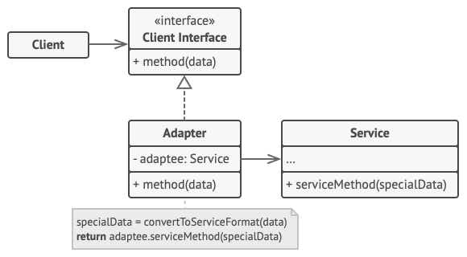

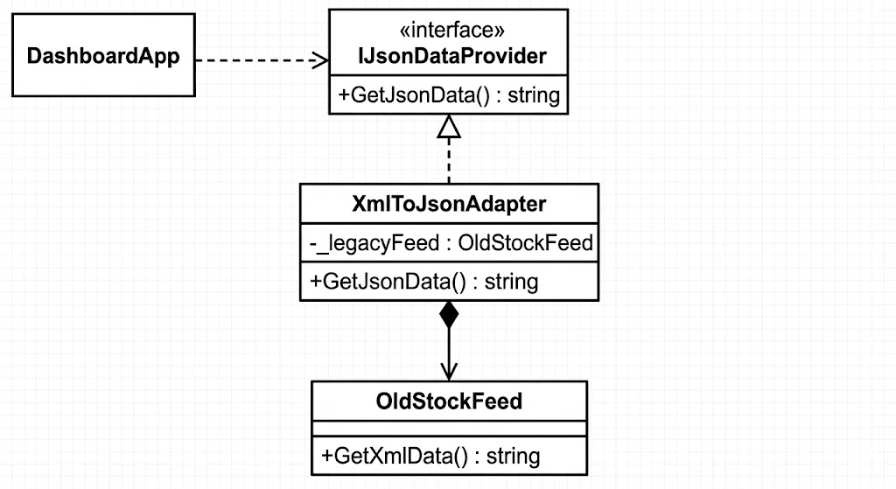

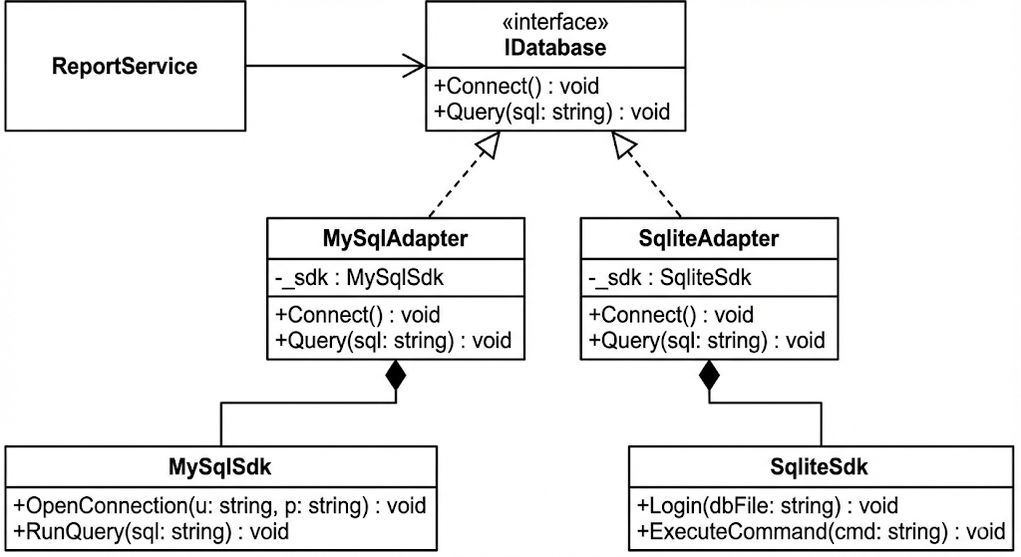

Pattern | Intent
Adapter | Changes the interface to match what the client expects.
Decorator | Keeps the same interface but adds responsibilities/features.
Proxy | Keeps the same interface but controls access (security/caching).

